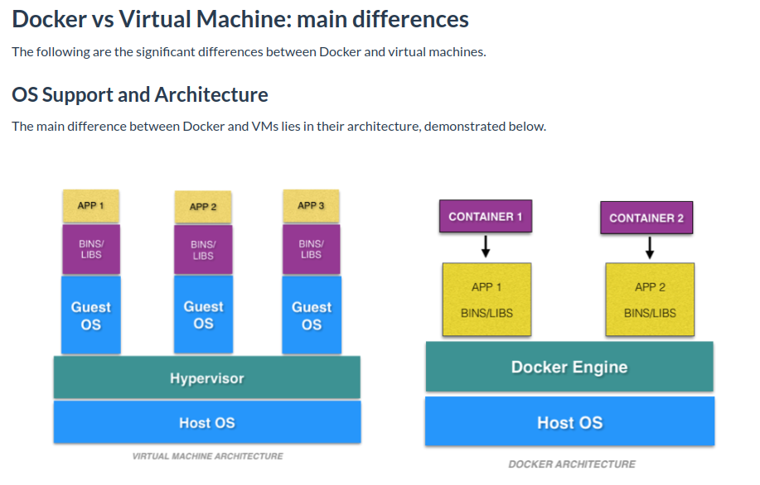
In virtual machines, there can be multiple different guest os each os has its own kernel. VM’s virtualize the hardware while the Docker virtualizes the OS. Docker containers are considered suitable to run multiple applications over a single OS kernel; whereas, virtual machines are needed if the applications or services required to run on different OS.

Virtual Machines are more resource-intensive than Docker containers as the virtual machines need to load the entire OS to start. The lightweight architecture of Docker containers is less resource-intensive than virtual machines.
In the case of a virtual machine, resources like CPU, memory, and I/O may not be allocated permanently to containers — unlike in the case of a Docker container, where the resource usage works with the load or traffic.

